Exercise 17
- Find and list the ids and spouse names of all employees who are married.
Answer: SELECT
emp_id,
spouse_name
FROM
employee_data
WHERE
spouse_name IS NOT NULL AND spouse_name != 'None' AND spouse_name != '';
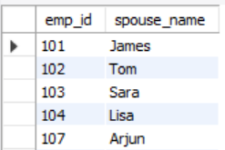

- Change the above so that the display is sorted on spouse names.
Answer: SELECT
emp_id,
spouse_name
FROM
employee_data
WHERE
spouse_name IS NOT NULL AND spouse_name != 'None' AND spouse_name != ''
ORDER BY
spouse_name ASC;

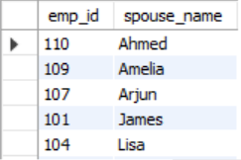

- How many employees do we have under each sex (male and female)?
Answer: SELECT
sex,
COUNT(emp_id) AS EmployeeCount
FROM
employee_data
GROUP BY
sex;
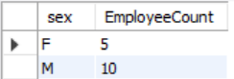

- How many of our employees are married and unmarried?
Answer: SELECT
p.marital_status,
COUNT(d.emp_id) AS EmployeeCount
FROM
employee_data d
INNER JOIN
employee_per p ON d.emp_id = p.e_id
GROUP BY
p.marital_status;
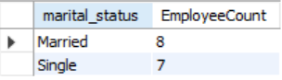

- Find the total number of children.
Answer: SELECT
SUM(children) AS TotalChildren
FROM
employee_per;

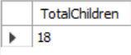
- Make unique groups of children and find the number in each group.
Answer: SELECT
children AS NumberOfChildren,
COUNT(e_id) AS NumberOfEmployees
FROM
employee_per
GROUP BY
children
ORDER BY
NumberOfEmployees DESC, children DESC;
